  - 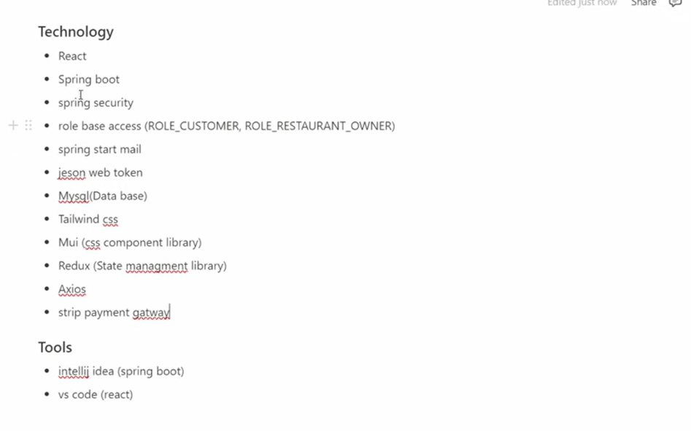
Postman
Postman in tools

Spring stat mail is used for notification like for forgot passward status of order

All about project structure etc
https://watery-lunaria-74f.notion.site/Online-Food-Delivery-Project-15d1b624e39247c989c893d425defdca
first spring boot project go in spring initilizer
